**Objective question 6**

(a) Well, yeah, paragraph C. Centripetal acceleration, straight up is absolute acceleration here. (b) Fact, paragraph A. The velocity at A is zero where the bob reverses direction. The movement is tangential, perpendicular to the line to the right and forward. (c) No. (d) Yes, article (B). Maximum acceleration is here downwards or upwards based on whether the centripetal acceleration is lower or greater than the tangential acceleration level.

**Objective question 9**

A > C = D > B = B = A 0. Centripetal acceleration is highest at constant motion because the distance is smaller. A straight line has a constant curvature radius. (b) the level at A is northward, B is westward, and C is southward. (c) Movement is to be significantly inward to the west at A, not present at B, and to the east at C.

Problem 22

Scroll down to see the pictures

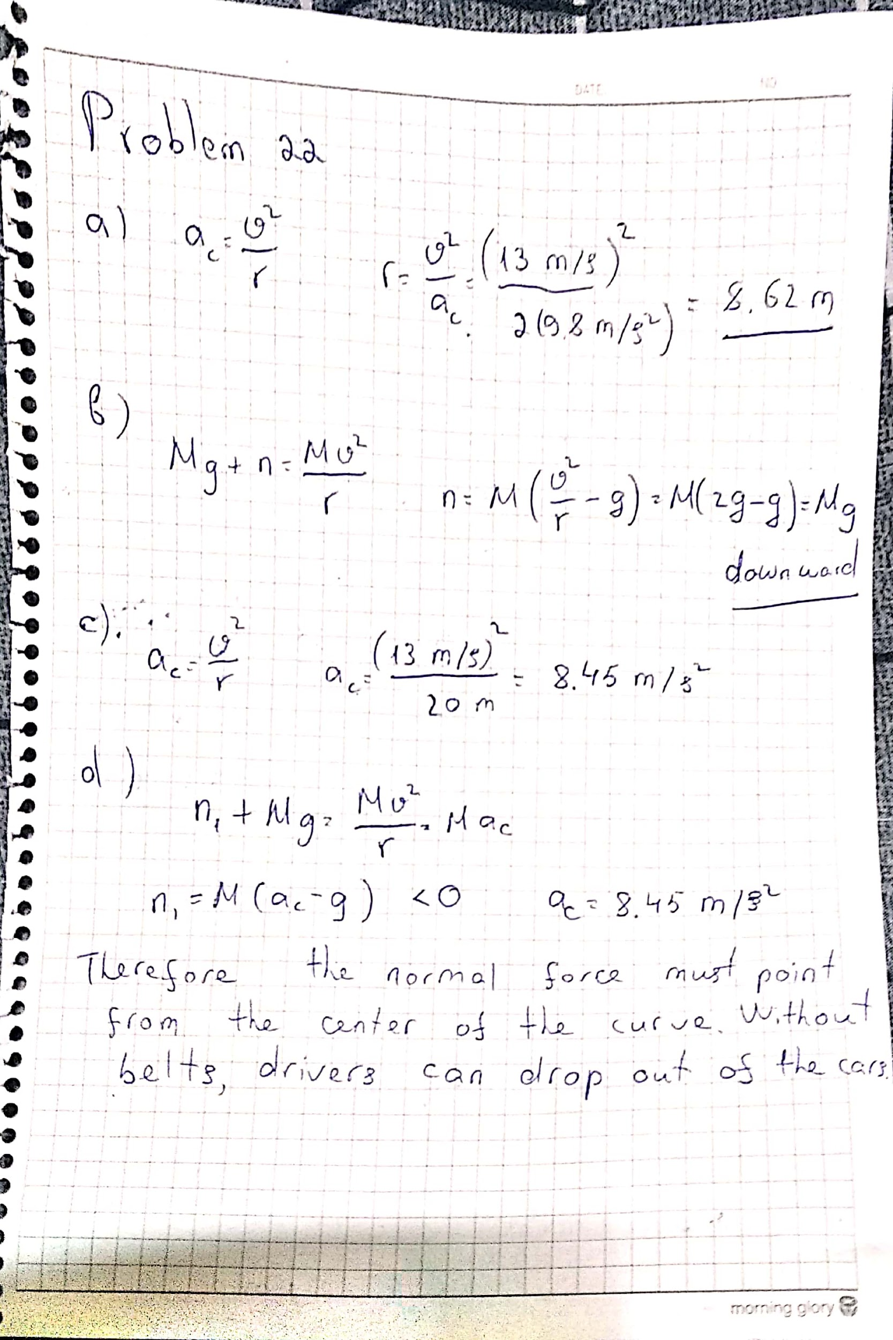

Problem 43

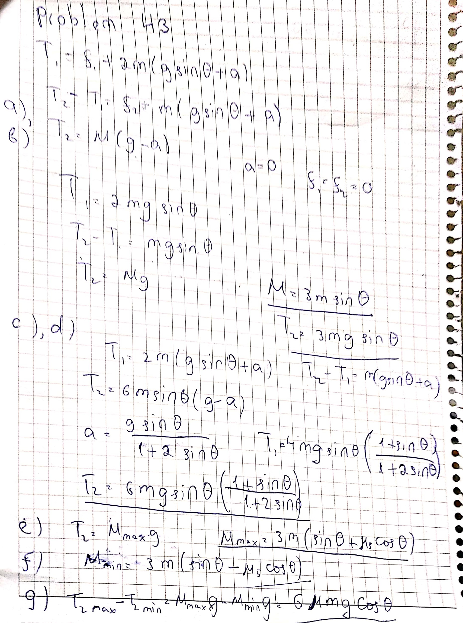

Thank you

Student Id : 201923250

Name : Kobilov Ilkhomjon